

Development Android

David LUONG  
C00221536

Web application

computer system management year 3

24 février 2017



Table of Contents

I. Introduction 3

II. Selection of the tools 4

III. My choice 4

a. Android Studio 4

b. Java 4

c. XML 4

d. Computer 4

e. Phone 5

f. Virtual phone 5

IV. Screenshot & Development 6

a. Changement of the icons of the App 6

b. Welcome Screen 6

c. HomeScreen 7

d. Personal detail 7

e. Education History 8

f. Employment history 8

g. Interest & Hobbies 9

h. Skills 9

i. References 10

j. Project work 10

k. About 11

l. Mail in the Clipboard & LinkedIn profile 11

V. Backup & Progression of the Project 12

VI. Problems 13

a. Design 13

b. Code 13

VII. Conclusion 14

# Introduction

The third and last assignment of Web Application is the development of an Android application. This application will be my Resume.

You will have the possibility to find below, which tools I decided to use and why this tools and not another one.

My principal objective has been to develop a flat design application and easy to use.



# Selection of the tools

To do this application, I had few option. You will find the different option below and they pros and cons.

Android Studio

|  |  |
| --- | --- |
| Pros | Cons |
| Official IDE of Android | Gradle can be very long |
| XML & Preview layout |  |
| Drag & drop |  |
| Support of community |  |

Android Studio have few advantages, the more important is the support of the community and the Layout view & Preview on the same screen.

Eclipse

|  |  |
| --- | --- |
| Pros | Cons |
| More stable than Android Studio | Should configure for Android |

As we can see, Eclipse is something like a neutral tool.

Buildfire

|  |  |
| --- | --- |
| Pros | Cons |
| Easy to use | Dependent on internet |
| Usefull for people who have no knowledge in coding | Codeless |
| Templates integrate | Paid option |
| Codeless |  |

I just talk about Buildfire, However, all the online tools got the same positive point and negative points. It can be a very useful tools for people who have no knowledge in coding. However, we are student, we should know who the development android is working and after use some “Framework”.

# My choice

## Android Studio

I decided to choose Android Studio instead of Buildire. I Could use Eclipse, however I prefer to have the official tools Android, in case of update of library of something else.  
Why? Because to me, those web tools is not really a Development Android, you just have to type your text and that’s all. It is not really development, it is codeless.

With Android Studio, you built your app from nothing. It is a real development.

## Java

To do the features, I used java. This language is very powerful. I already used it so it is a positive point.

## XML

The XML will be used for the designing of the layout. All pages will have his own layout. This language allows us to transmit data.

## Computer

I decided to work on my own personal computer. Thanks to this choice, I had more flexibility and more possibility instead of using a computer at the IT.

You will find bellow the configuration on my Pc to run Android Studio.

CPU: Intel core i7 6700HQ (4 cores, 4 threats, 2,6GHz up to 3,5GHz)  
GPU: GTX 960M  
RAM: 8go DDR4  
HDD: 1To  
SDD: 250go Crucial  
OS: Windows 10 Professional

As I wrote, the Gradle can be very long, that’s why I installed Android Studio on my Solid State Drive. Thanks to this, the gradle is very quick

## Phone

To check the application during the development, I used the virtual phone of Android studio, but also my personal phone.

To me we don’t feel the mobile application on the virtual phone, you should have the application in the hand to see if it is intuitive and easy to use. It is like if you read a book in paper and the book in e-book version, you will not feel the same because with the e-book it is not really a book. Instead of the version paper it Is different. So, it’s the same with the mobile application.

CPU: Kirin 935 (Octa-Core 2.2GHz)  
GPU: Mali-T628 MP4  
RAM: 3go  
HDD: 16go Samsung  
SD Card: 64go Toshiba  
OS: Android 6.0 Marshmallow  
screen definition : 1920x1080

## Virtual phone

I also used the virtual phone of Android studio who is a Google Nexus 5.

# Screenshot & Development

1. Modification of the icons of the App –

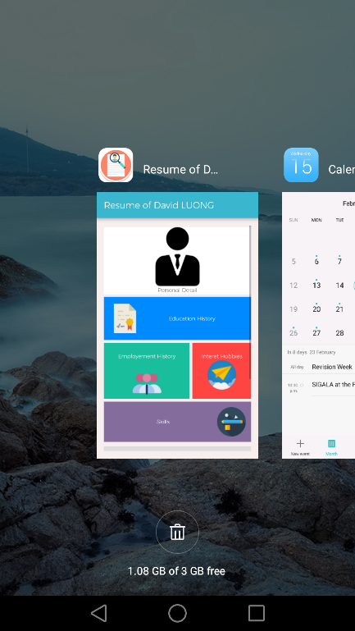

I have changed the default icons of the app. The default was the Android icon.

The modification has been done in the Manifest





1. Welcome Screen -MainActivity.java / activity_main.xml

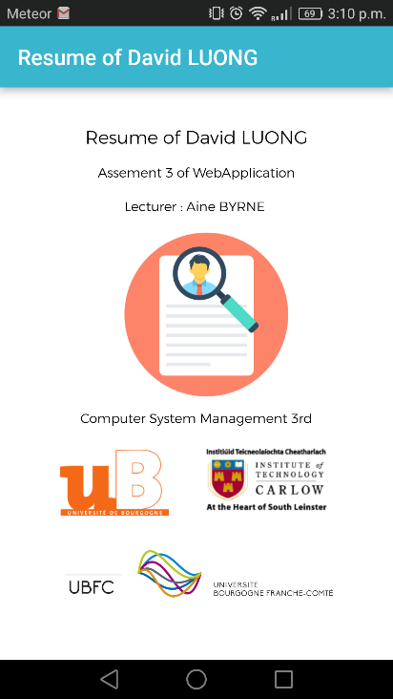

When we open the application, before to be on the home screen, we will have a WebcomeScreen with the title of the application and few details. To design this page, I used few TextView and few ImageView.

1. 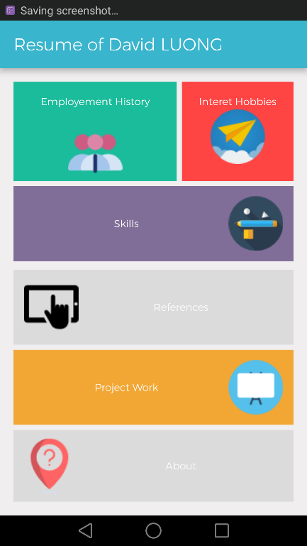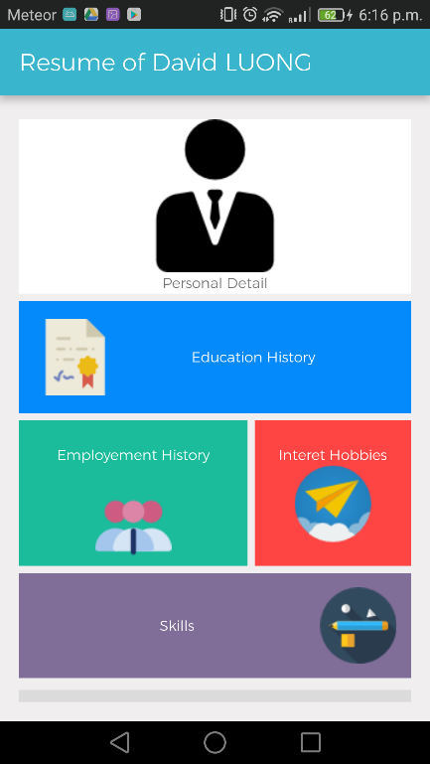HomeScreen – HomeActivity.java / activity_home.xml

The home screen will contain the different part of the curriculum vitae, the user will decide which section he wants to see.

I used a ScrollView and few TextView.

1. 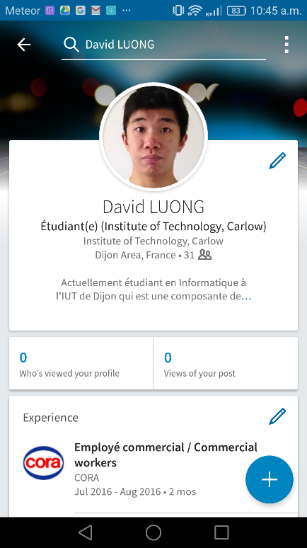Personal detail – personal.java / activity_personal.xml

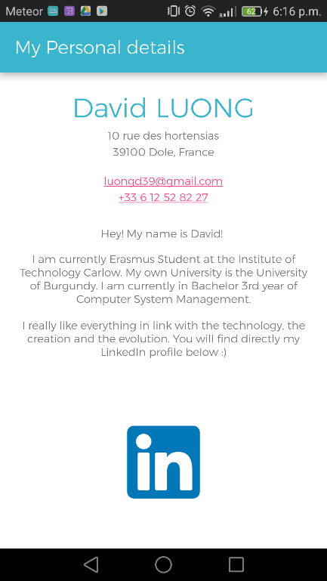

This parts contain my personal detail and a redirection link to my LinkedIn profile. If the user touch my mail or my phone, the app will directly call the app to contact me. (Mail or Phone)

1. 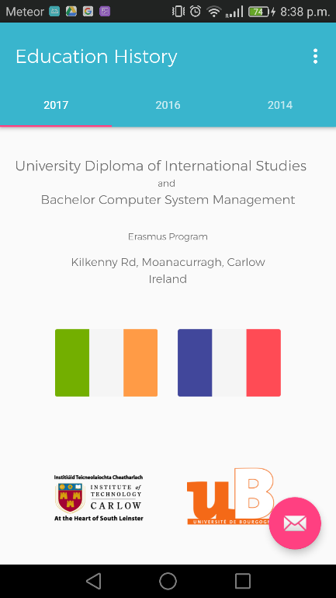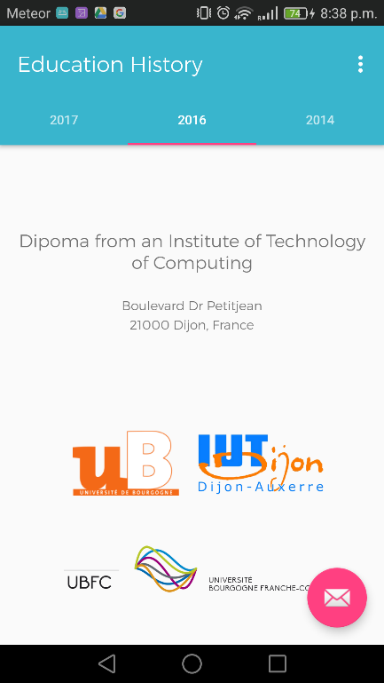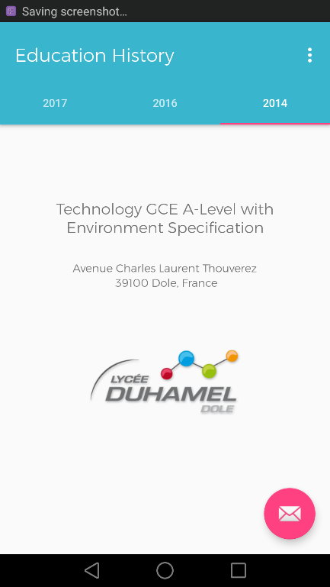Education History – education.java / educationtab1.java / educationtab2.java / educationtab3.java / educationtab1.xml / educationtab2.xml / educationtab3.xml

For this part, I used a tabbed activity to separate each degree. Each School have is own redirection is the user select one. Each college has his own redirection. Moreover, if you touch the letter in the corner, my mail will be directly added in your clipboard.

1. 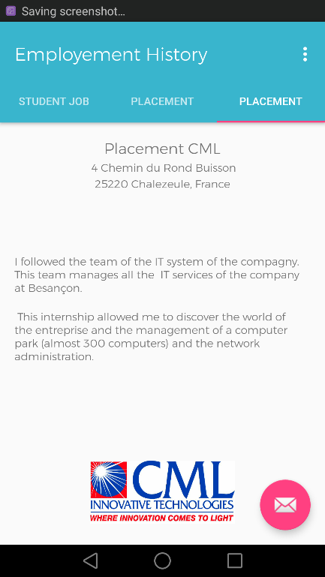Employment history – employementtab1.java / employementtab2.java / employementtab3.java / employementtab1.xml /employementtab2.xml / employementtab3.xml

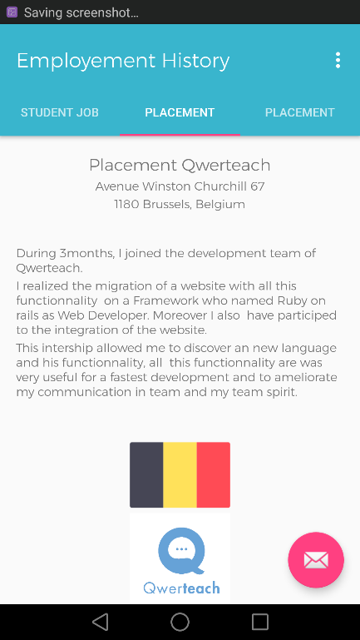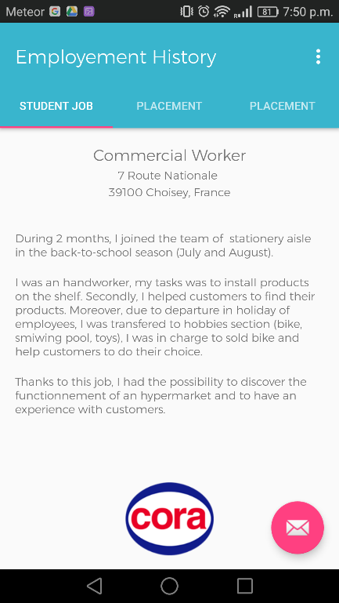

For this part, I used a tabbed activity to separate each employment history.

1. 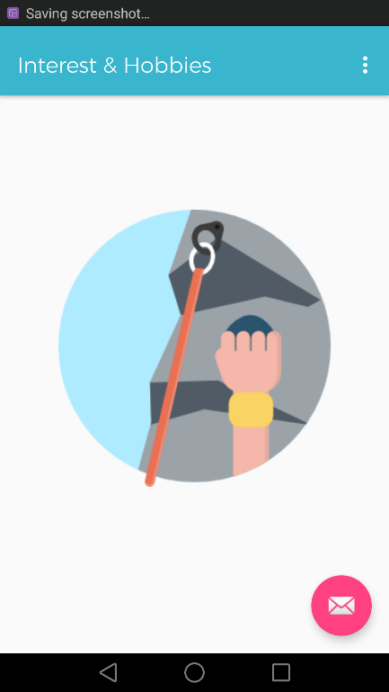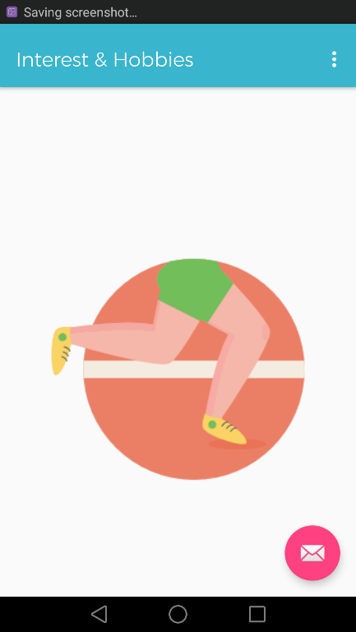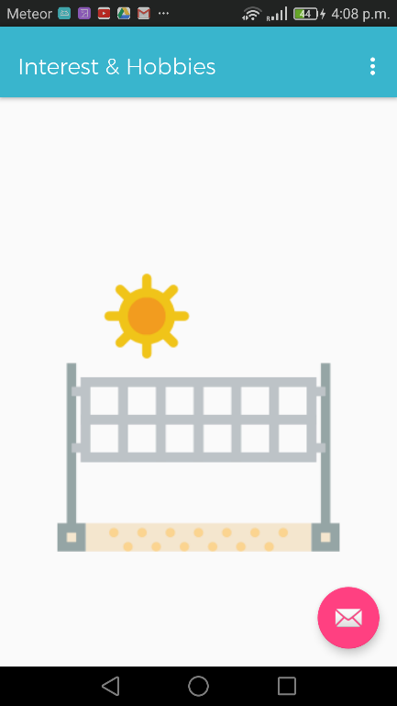Interest & Hobbies –interet.java / interet1.java / interet2.java / interet3.java / interet4.java / interet5.java / interet6.java / fragment_interet.xml / fragment_interet1.xml / fragment_interet2.xml / fragment_interet3.xml / fragment_interet4.xml / fragment_interet5.xml / fragment_interet6/xml

For this part, I used a tabbed activity, to see each interest or hobbies, you have to slide on the right or on the left. We have 6 different page. However, I show you only 3 in the report.

1. 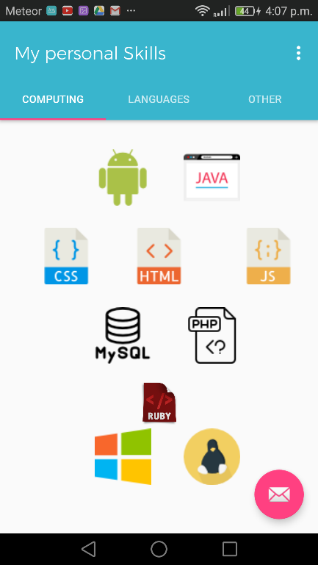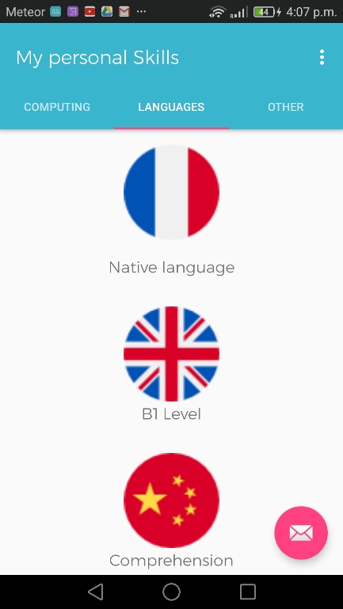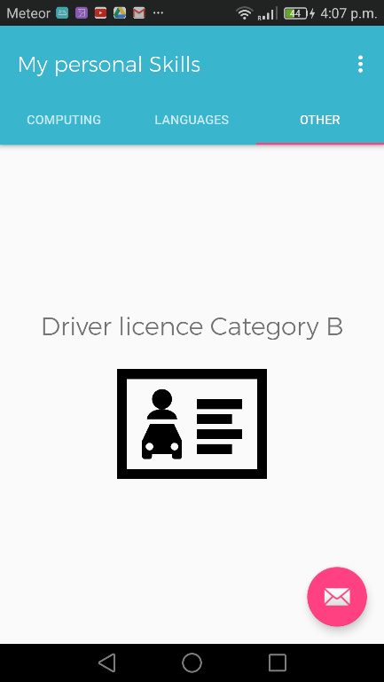Skills – skill.java / skill1.java / skill2.java / skill3.java / activity_skill.xml / fragment_skill1.xml / fragment_skill2.xml / fragment_skill3.xml

For this part, I used a tabbed activity to have sub division for the skills. (Computing, Language and others)

1. References – ref.java / activity_ref.xml

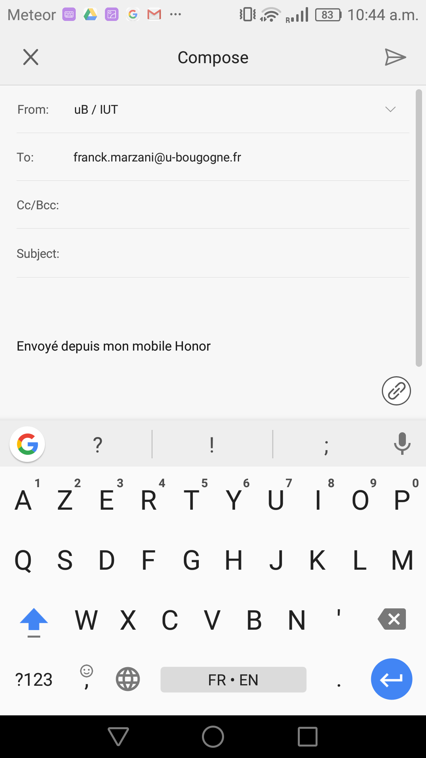

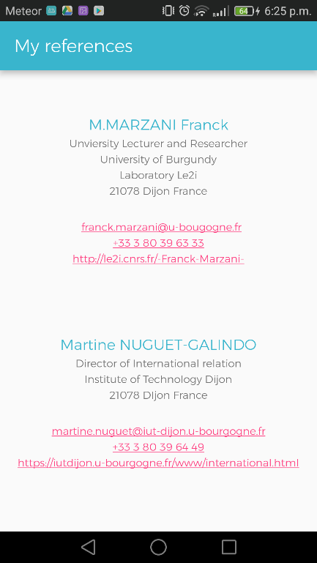

For this part, I used an empty activity. I just put few textView to show few details of the people. Moreover, if the user touch directly the number phone or the mail

1. Project work – project.java / activity_project.xml

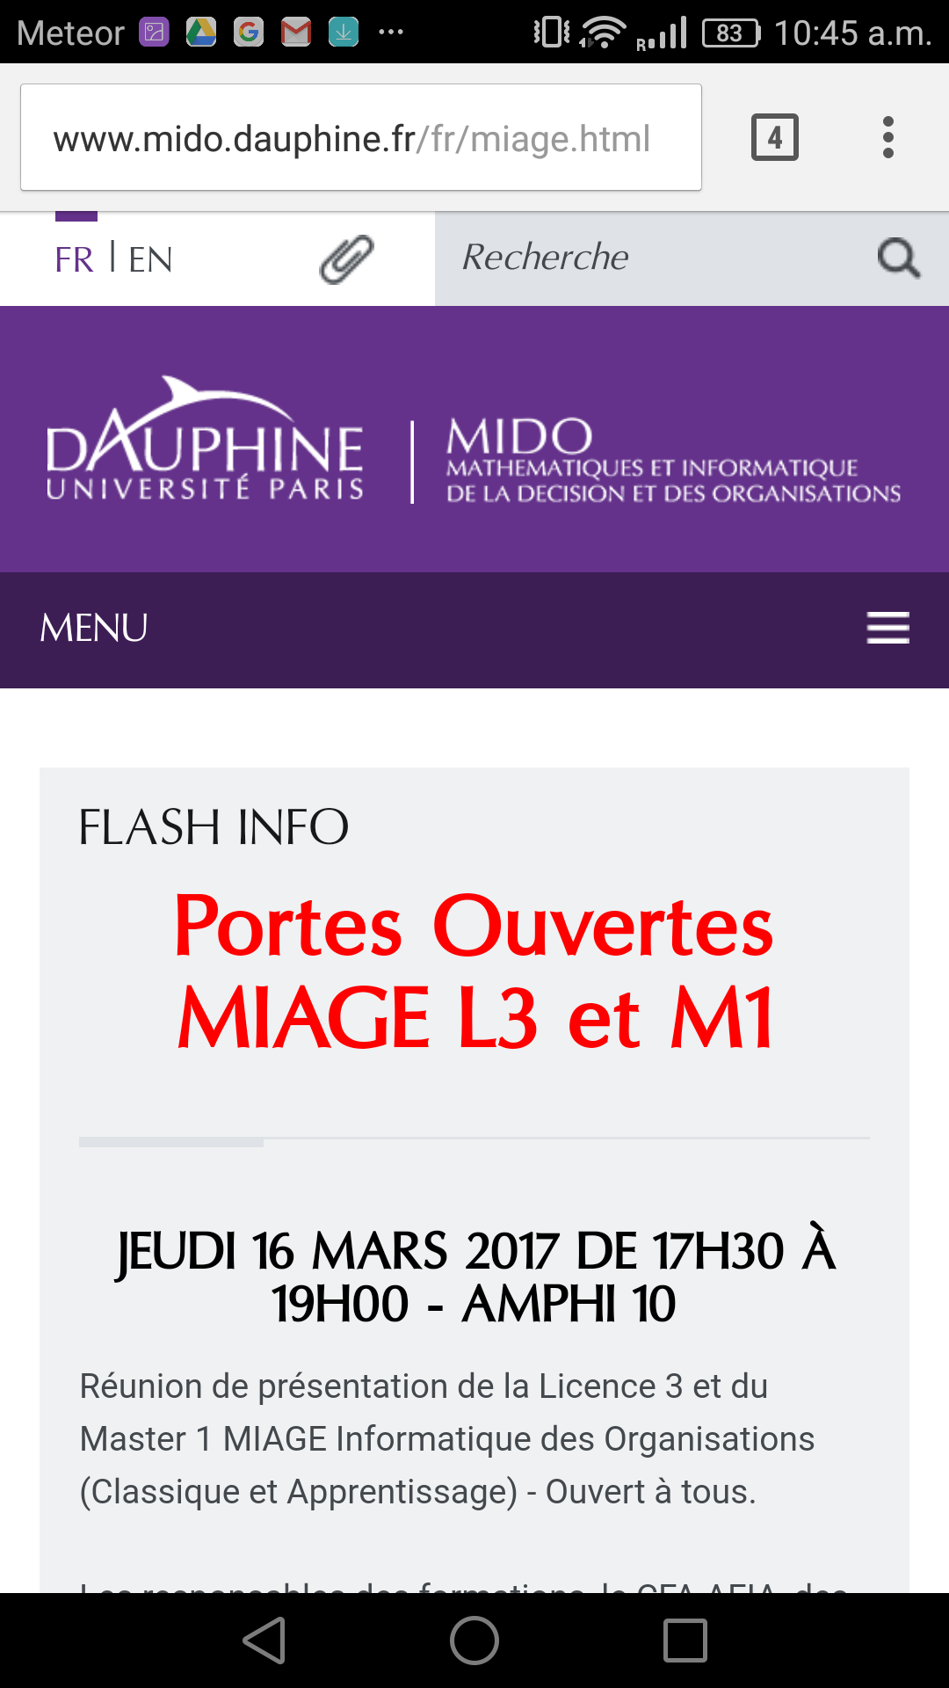

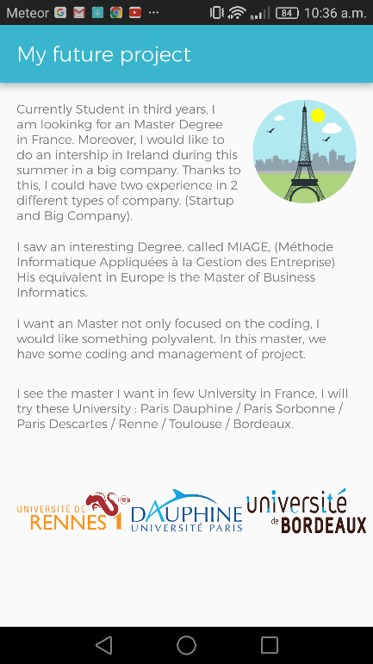

For this part, I used an empty activity, the objective is just to show my future project. I used few TextView, few ImageView. And each ImageView have a redirection into the website of the university selected.

1. About – about.java / activity_about.xml

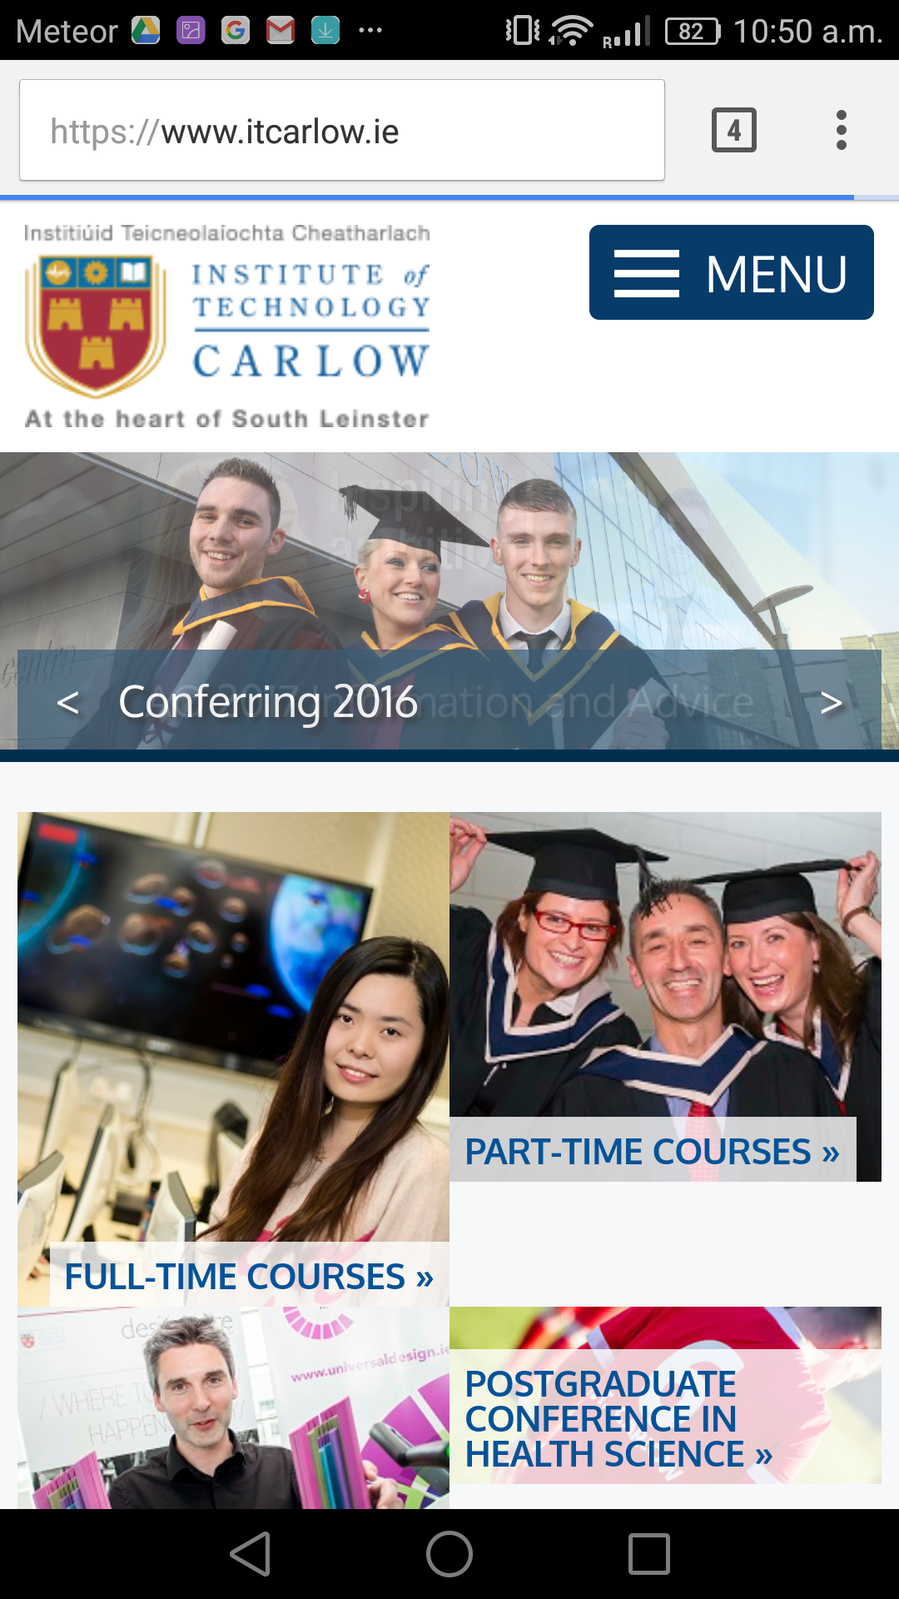

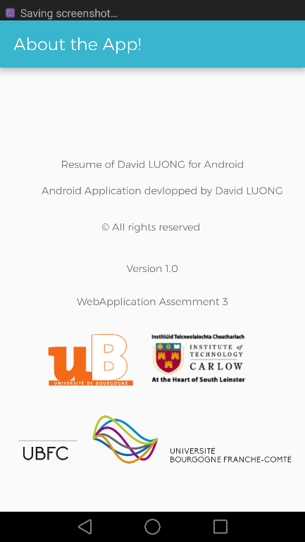

This part was optional, this part is just to show the “Why” and “Who”, the application. I used few TextView and 3 ImageView. Each image has a redirection to the website of the University selected.

## Mail in the Clipboard & LinkedIn profile

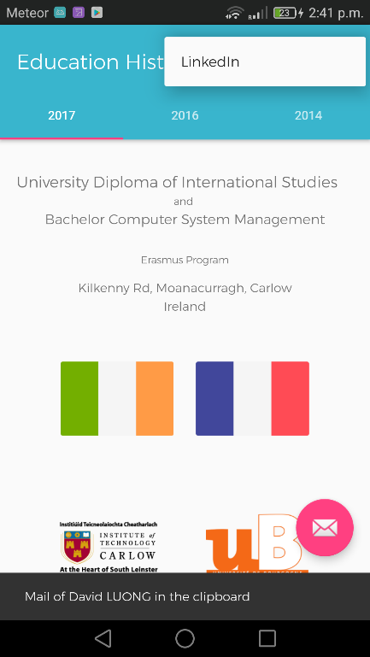

Each time you can see the title letter in the corner, that’s allows you to copy my mail in the clipboard. Moreover, in the menu in the top, you have a redirection in my LinkedIn profile.

# Backup & Progression of the Project

To back up my project, I decided to use GitHub. Thanks to this utility tools I have a view of all progress of my project and every modification I did.

For each progress in the project, I use these command in my command prompt GitShell :

Git status: Check which files has been modifying or added to the project

Git add.: Update the index with all files modify or created

Git commit: Add the modify, created files to the local repository.

Git push origin master: This command sends all the modify to the remote repository.

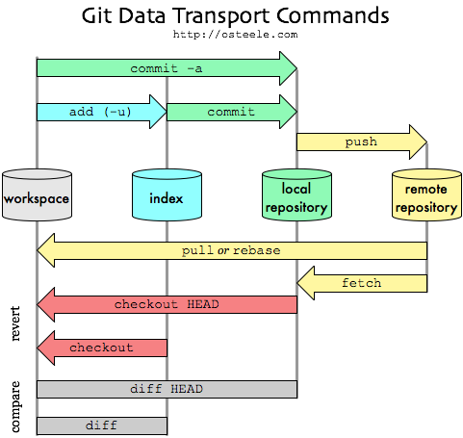

Normally, I shouldn’t work on the Master branch. The master branch is the main line of the project. But in my case, I can work on the master branch because I am alone on the project.

If we were in team in the project each members of the group should create on his own branch and work on it. And when someone finish his features, he can push on master.

You can see the following schema bellow. If few people modify on the same file, when we push on master branch, we will have the choice to delete one part the code or keep it.

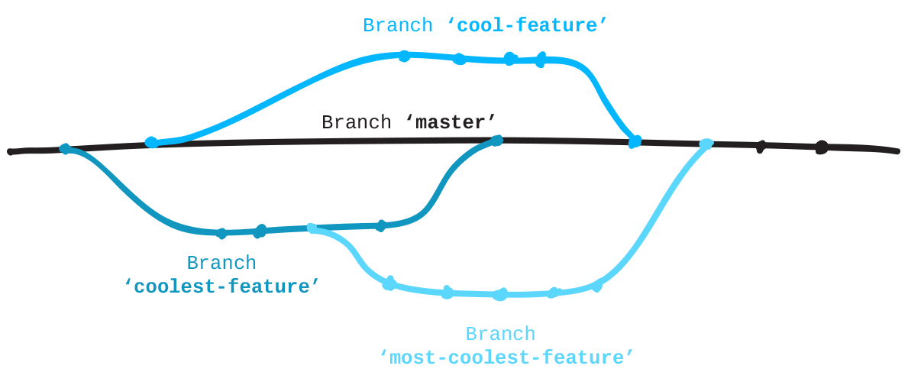

GitHub is a very powerful tools, it is like SVN however after use, I personally prefer GitHub that’s why I decided to use it to back up my project and I will re-use it for the next project.

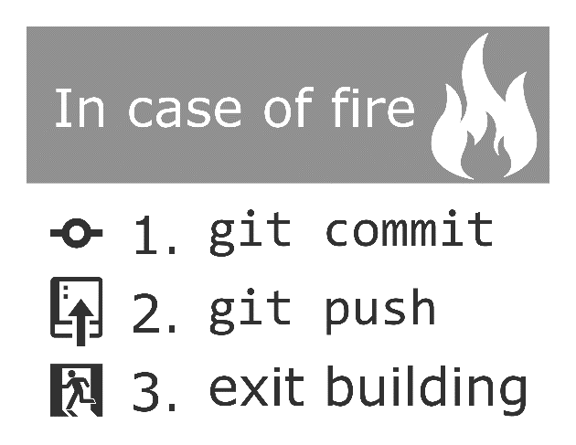

You have the possibility to download the project to this link:

<https://github.com/c00221536/WebAppAndroid>

# Problems

## Design

I really want something simply and beautiful. That’s why I decided to focus my design on the Flat design. As we can see on the application, we have simple colors and minimalist.

## Code

About the development, I had few problems to solve, to solve it I was looking on **StackOverflow**. The Android community is important and active. It wasn’t difficult to find solutions to my problems.

However, I have one problem about the development The problem was the change de default font for the whole app, I was totally sure it was possible. Nether less, it is not possible, currently we have 2 options, the first one is to get all textView id we want modify and set the custom font. The second option is to use a library called Calligraphy developed by Chris Jenx.

Thanks to this, I just had to follow the instruction of the developer on GitHub to set my custom Font.

Calligraphy repository: [https://github.com/chrisjenx/Calligraphy](https://github.com/chrisjenx/Calligraphy%20)

# Conclusion

This assignment was really appreciating. The app will be useful for the recruiter when we will do some interview. It is really something who can be useful.

I really enjoying developing this application. However, if I could show it to a recruiter, I don’t know if I will. If I have to show my curriculum vitae in mobile version I will do a another application who will be more clean. May I will use an online tool to do it.